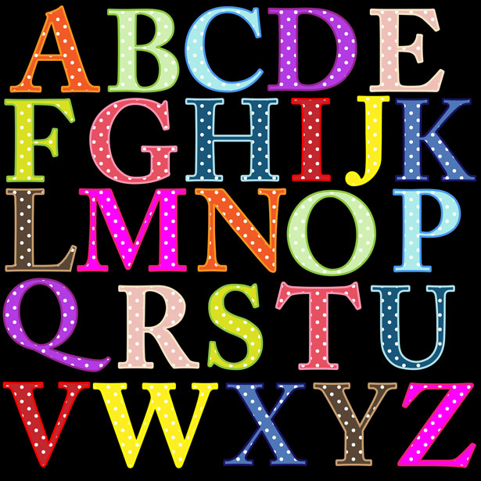

**15 Reading Activities for Kindegarten and First Grade**

1. Practice writing the upper-case letters.
2. Practice writing the lower-case letters.
3. Identify and practice the name sound of the letters.
4. Give your child five words and have them determine the beginning sound of the word.
5. Give your child five words and have them determine the ending sound of the word.
6. Give your child a word and ask them to provide you with a word that rhymes.
7. Give your child a word and ask them to provide you with a word that has the same beginning sound.
8. Give your child two words with the same beginning sound and ask them to tell you the letter and sound of the initial sound in the word.
9. Give your child three words - two with the same first letter and one that is different – and ask them to listen for the word that is different. Have them tell you the letter and sound for the different word.
10. Segment and blend consonant – vowel – consonant (CVC) words. CVC words are three letter words like *cat, hid* or *pig*.  When we segment words, we break them into parts according to each letter sound so cat would be /c/ /a/ /t/.  When we blend words, we orally take a word and break it into parts so that each letter sound can be heard.  From /c/ /a/ /t/ the students would blend the sounds together to make the word “cat”.
11. Writing and reading CVC words in isolation.  When we do this, we say the sound for each letter and then write the letter or use magnetic letters to match the sound(s) to spell the word.  Once our words are written or built, we go back and read the words.
12. Get your favorite book and create a new cover for that book.  Be sure to include the title, author, illustrator and a picture.
13. Read a fiction book with someone at home.  At the end tell that person these things: characters, setting, problem, solution.
14. Read a non-fiction book.  Before reading tell two things that you already know about this topic.  Preview the book and list 2 things you would like to learn while reading.  After reading, tell 2 new things that you learned from the book.
15. Reading and writing the sight words